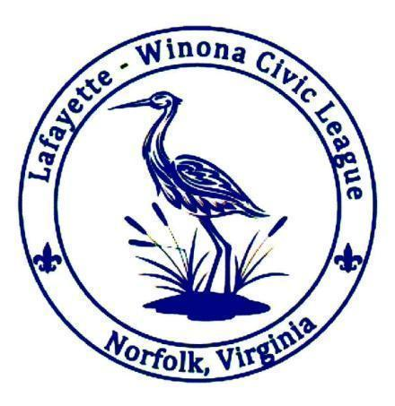
Lafayette-Winona Civic League
Minutes of the LWCL Meeting
June 16, 2026

7:00 pm - Call to Order and Pledge of Allegiance
Welcome to the 2025/2026 Civic League Season

Board Members:
Bryan Cornell, President
Matt Hinson, Vice President
Nancy Eyler, Treasurer
Christopher May PhD, Secretary
Douglas Arnold, Member at Large

Attendance:

WELCOME TO NEW MEMBERS!

Introductory Announcements by our Vice President (President Cornell is unable to attend this evening)

Officer Tomko
- Office Tomko was unable to attend this evening

Special Guest Shawn Wilkerson
- Running for Norfolk School Board – WARD 2
- Three pillars of his platform:
  - Families first
  - Accountability
  - Transparency
- Shawn is retired Navy, has 3 children in enrolled NPS, Norfolk resident for over 20 years, and is a Scout Master. He currently works as a Systems Engineer (and gave a wonderful description of what systems engineer does)
- Proposes PTA for every school
- Balanced spending – administrative audit to possibly redirect funds where needed

Committee Updates
- Events – Amanda Pine
  - Meet and Greet in August in lieu of June meeting
  - New Co-Chairs were presented for the committee
- Social – Rebecca Shultz
  - Need someone to manage the soical events committee and run the FB group
  - Please let Rebecca know if you are interested
  - Greater Lafayette Advisory Board is meeting on June 25th at the Chuch
  - LWCL will not have meetings in July and August
- Dog Park – Susan Jones
  - Mulch – City does not have the mulch yet and we continue to request updates
  - Complaint on the water bowl that it is too big
    - It is now missing and a bucket is in its place
    - Doug will bury a new bowl so it can’t be knocked over
- Traffic
  - Survey was conducted and is now closed
  - Matt will work to get a new presentation from the City on the survey results

LWCL Board Swearing In

The new LWCL Board is sworn in by Mamie Johnson, City of Norfolk Council Woman

The 2026/2027 New Board as Elected and Sworn in on this Date, June 16, 2026:

Kelsey Backe, President
Amanda Pine, Vice President
Rebecca Schultz, Secretary
Margaret Gemski, Treasurer
Douglass Arnold, Member at large

Special Guest Speaker – City of Norfolk City Council Member Mamie Johnson serving Ward 3
- Council Woman Johnson serves as our conduit for our concerns and issues
- Suggests sending issues through Norfolk Cares System but also contacting Council Woman Johnson as well so she can follow up with submitted concerns
- Traffic survey is now closed – once closed it is time to move toward solutions – the longer the survey is open, the higher the costs
- The Greater Lafayette Advisory Board is meeting on June 25th at 6:30 at the Church and this is the forum to get an update on where we are on the traffic solutions
- Understand how our City works! Use the resources available and use the City Council to address the needs our community has – attend the Advisory Board, City Council Meetings and keep in touch with Council Woman Johnson
- Get a plan for the civic league needs, formalize it and address!
- Halima handles Norfolk Cares and will introduce us on how to connect with the City:
  - Norfolk Cares – use the website!
    - Make service requests
    - Also tracks service requests by neighborhood
  - It is easy to get connected (many ways to do so!):
    - Sing up for City updates www.norfolk.gov/list.aspx
    - Resident monthly e-newsletter – can have this mailed directly to you
    - City Manager’s Friday Packet – sign up!
    - Norfolk TV App – live broadcasts and on-demand content from the City
    - City Hall Information Desk – citizen service ambassadors are there to answer your questions
    - Department of Neighborhood Services:
      - Bureau of Neighborhood Quality
      - Bureau of Neighborhood Engagement
      - Rent Ready Norfolk
      - Eviction Protection Center
- Ashland Pump Station Replacement Project
  - Work is progressing on to Holland Ave – second week of June
  - Should be complete by the end of this year
  - After that the portion of pipeline on Luxembourg Street must be redone due to inconsistent grading issues
  - Entire project done in Summer of 2027\Contact Phil Hubbard at projects@hrsd.com or Onsite inspector, Bob Doyle 757-382-0109

Good for the Order
- None this week!

Treasurer’s Report: Nancy Eyler
- Total: $6,856 in general fund
- $1,400 in dog park fund

Last Meeting’s Minutes
- May’s meeting minutes are approved and available on the LWCL.net website

Next meeting date: September 15th, 2026

Adjournment at 8:00 PM

Check out the website: www.lwcl.net


