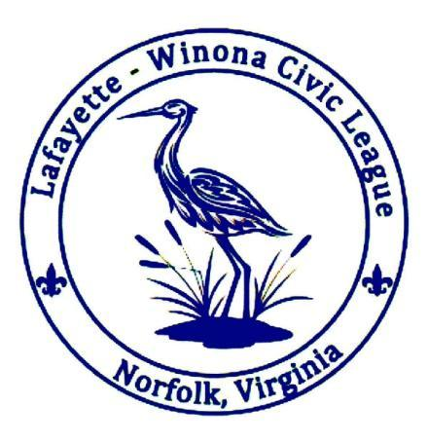
Lafayette-Winona Civic League
Minutes of the LWCL Meeting
September 16, 2025

7:06 pm - Call to Order and Pledge of Allegiance
Welcome to the 2025/2026 Civic League Season

Board Members:
Bryan Cornell, President
Matt Hinson, Vice President
Nancy Eyler, Treasurer
Christopher May, Secretary
Douglas Arnold, Member at Large

Introductory Announcements
- HRSD cancelled their presentation – will be rescheduled for future meeting
- Appreciation for attendance expressed

Special Guests and any First-timers Introduction
- HRSD Cancelled due to weather concerns

Attendance: 46

Last Meeting’s Minutes
- Summary of July/August Board Meetings by Bryan Cornell
  - Webpage launch (www.lwcl.net)
  - Committee establishment

Crime Report by Community Resource Officer, Officer Tomko:
- 60 day stats
- No violent crime reported
- Several petty larcenies reported (car break-ins)
  - Main dates for reported incidents were in early August all over the neighborhood
  - One car window broken
  - Norfolk PD Sponsored Event this Saturday (9/20) @3PM Grace Baptist Church
    - 3423 Sewells Point Road, Norfolk
  - Oct 1 Chat and Chew – Walk with Norfolk Police officers through Norview Neighborhood: meet at Norview Community Center 6PM
    - 6380 Sewells Point Road, Norfolk
    - City will provide food and drinks after
- Member Question: What is going on with the intersection across the bridge? DuPont Cir and Lafayette – the crosswalk signal is no longer working (button is gone/no power). Brian Cornell adds that a Hawk System may be proposed by City? Hawk System is a cross walk with yellow and red signal light to assure traffic stops to allow crossing. Member of the City of Norfolk Traffic department will come to a future meeting to answer questions on Hawk system
  - We did have flags at the intersection and the City took them away as they were not “authorized” – Officer Tomko took not and will inquire on this for next meeting

Introduction of Committee Chairs
- Board established a committee system – 3 committee system
  - Goal for system is for the members to have the power to give direction to the civic league
  - Committee participation is voluntary
- Committee chair goals and how to get involved
  - Events Committee – Amanda Pine
    - Introduction of current members
    - Some events already proposed!
      - Halloween decorating competition
      - Xmas light tour with stops
      - Yard sale
      - End of school year/beginning of Summer event
    - Amanda requests that interested members reach out to her to take part in the committee
  - Social Committee – Rebecca Schultz
    - Introduction of members
    - LWCL Website is up and running
      - Event calendar is up and running on website
      - Website now includes a document library
      - Rebecca’s email is on the site – email her with ideas/comments/additions
      - Website will include a subscribe form for newsletter/announcements
    - Formal FB code of conduct – in the works
    - Goals:
      - Want to move primary form of communication out of FB and on to the website – STATED GOAL
      - Newsletter with contributions – STATED GOAL
      - Redesign of the civic league signs is in the works!
      - Colonial Pace Riverview has sponsors for their website AND their newsletter – Social committee seeks similar avenue to gain sponsors to cover costs and possibly bring in money to the LWCL - STATED GOAL
      - Dues paid online/information collected online through website – STATED GOAL
  - Dog Park Committee – Susan T Jones
    - Recounting of the history of our dog park
    - Susan would like to work with volunteers on upkeep
    - Need more volunteers – maintenance and monitoring of the park
      - City does not do much in this respect so the reliance on volunteers is crucial to the upkeep of the park
    - Please get in touch with Susan for volunteer opportunities!!

Special Guest Presentation by HRSD/ Hazen & Sawyer
- Cancelled

Good for the Order
- Member input
  - Amazon wreck on Lafayette – video was made by civic league member – Lafayette and Dupont Cir
  - Video captured sound of neighbor saying to throw dog poop in yard
  - Last straw for this member and he is selling home
  - Urges civility in the neighborhood
- Member input
  - Comment from member on Dupont Cir: past 3 weeks she has been doing a walking challenge – noticed that the sidewalks on South side of Lafayette are really bad (some are marked orange for possible replacement?)– Does Norfolk have a request form to replace sidewalks? If so, suggested we should come together as a civic league to address this problem – possibly place link on website for the NORFOLK CARES form
    - (possible follow up action for Social Committee – NORFOLK CARES link
  - 2nd Member response: Replacement of water lines may be cause for the marks that have been spotted on the sidewalks (Miss Utility uses orange marks for communication lines)
- Member input
  - Motion form member that the committee chairs are allowed to vote with the board – they would essentially become members of the board with voting priviledges
  - Motion is seconded
  - Reasoning is to bring more voices on the board
  - The motion would be to open a conversation to amend the by-laws to allow committee chairs to vote as full board members
    - Rebecca – this could be an opportunity for members to gain experience in the civic league and possibly
  - Call the Question (vote on the motion) – those in favor of examining an amendment to the by-laws to allow committee chairs to be members of the board voice ‘yay’ - those opposed voice ‘nay’
  - Motion passes
- Announcements:
  - Please provide email address to Rebecca Shultz for inclusion in newsletters/announcements of the LWCL
  - Announcement: Oct 18th Epiphany Church yard sale – food and bake sale!
  - Announcement: meetings will be videoed and made available for homebound members
  - Announcement: Oct 4th and 5th at Lakewood park – art sale!
  - Announcement: First UMC: Fall Festival Nov 1 -5 PM
  - Announcement: Katy’s Kickers Swim School opening this month Sat the 27th on 2601 Colley Ave. Invitation to attend grand opening by owner

Treasurer’s Report: Nancy Eyler
- LWCL financial state
  - August –
    - 3 people joined: $15 for membership
    - LWCL paid $383 to get website up and running
  - Sept –
    - 2 people joined: $10 for membership
  - $5320 in the general fund
- Membership dues – if you have not already, please pay Nancy ($5 payable to treasurer)

Next meeting date: October 21, 2025

Adjournment

Check out the website: www.lwcl.net


